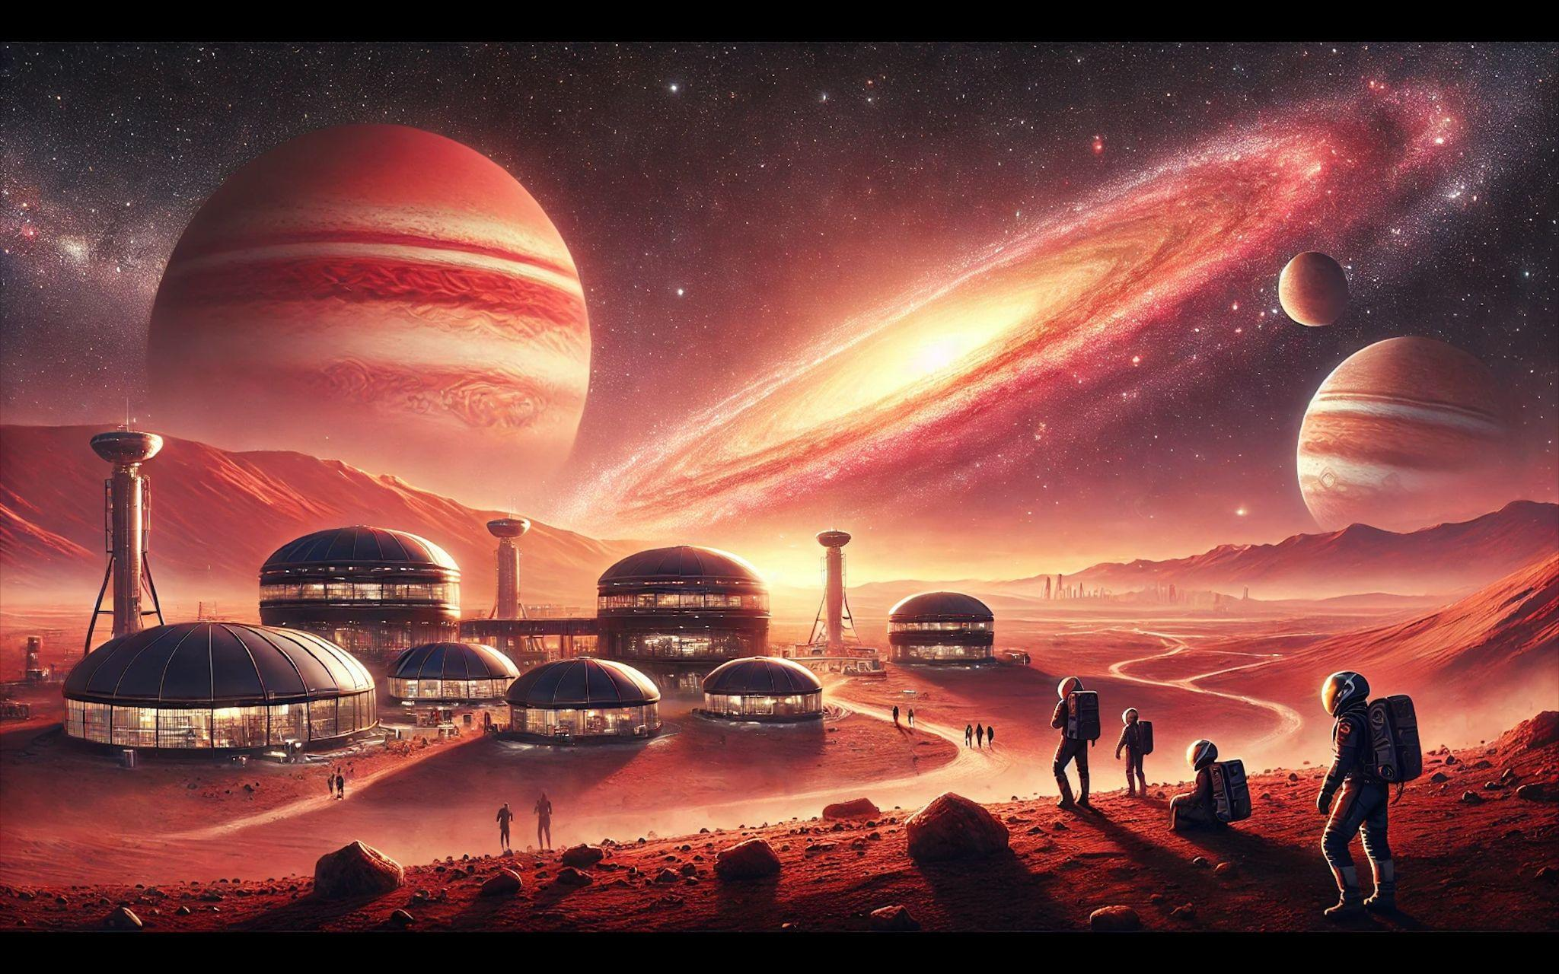

Prompt:

A vivid image of a futuristic Mars colony, bustling with human activity under a pinkish-orange sky. In the background, the enormous asteroid belt stretches across space, with the gas giant Jupiter looming nearby, casting a soft, ethereal glow. Farther still, a radiant quasar shines, adding a cosmic wonder to this Martian settlement scene.

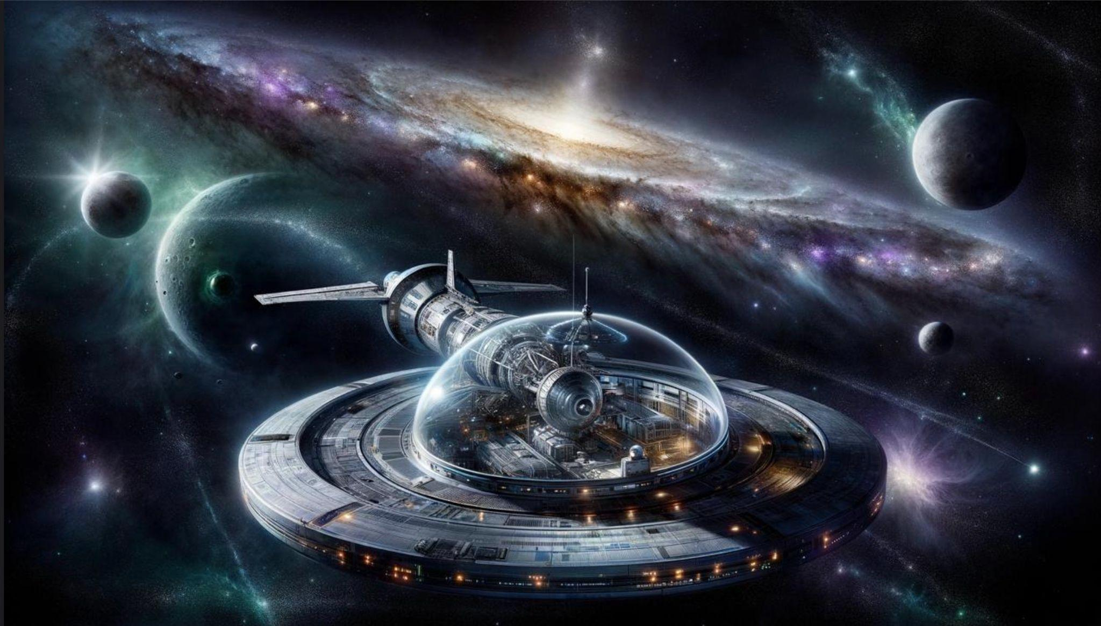

Prompt:

A scene set in deep space, far from any known planet. A sleek, silver spacecraft drifts in silence, casting a soft, metallic glow under the ethereal light of a nearby nebula in shades of purple, blue, and hints of green. Behind the spacecraft, stars twinkle against a deep black sky, and a massive, distant galaxy looms with swirling arms and glowing cosmic dust. The ship’s observation deck has a large, transparent dome where an astronaut in a futuristic suit gazes out, mesmerized by the spectacle. A mysterious asteroid belt encircles a darkened, uncharted planet on the far side of the scene, as if holding ancient secrets from another time.